Note: This document is “view only”. Please create a copy of this document and save it to your drive.

**SOP- Monthly Metrics- Systems Vault**

**PREREQUISITES**

[Master: SOP- Metrics - Systems Vault](https://docs.google.com/document/u/0/d/1R2L8bjwos9LwUZcVbuGmYS2mSQWj5vWXTGoV-vsrO14/edit)  
[Master: Metric & KPI Planning & Tracking- Systems Vault](https://docs.google.com/spreadsheets/d/1OTXpFNDUCOTQ1BeItyQ49McrzLW6TKo5H906EhZC2Dc/edit?usp=sharing)

[Google Analytics](https://analytics.google.com/analytics/web/) - sarah@sarahnoked.com

[Ontraport](https://ontraport.com/)

[Loom](https://www.loom.com/)

[Teamwork PM](http://sarahnoked.com/teamwork)

[Master: URLS (master links)- Systems Vault](https://docs.google.com/spreadsheets/u/0/d/1mlQjpjNMlD4NJVtNFufaUVEE326vNw4TkKrwULAD43U/edit)

**PURPOSE**Tracking metrics and key performance indicators monthly gives us insight into how the business is performing and enables us to make business decisions backed up by numbers. Tracking metrics monthly also allows us to see trends emerging.

**POLICY**

Metrics are tracked monthly and updated here [SN Master: Metrics](https://docs.google.com/spreadsheets/d/19wmGf9HFWkDmUCWjUwcCZK_6MeDgxJS05N9-6SPo07I/edit?usp=sharing) in the tab “2020- Monthly KPIs & Metrics”

There is a recurring task in [Teamwork](https://sarahnoked.teamwork.com/#/home/projects) to track report metrics monthly.

Metrics are reported via [Loom](https://www.loom.com/) Screencast and sent through the INTERNAL channel in [Teamwork Chat](https://sarahnoked.teamwork.com/chat/channels/55606) with a mention to @all

Color the stats **green** for positive/increased results and **red** showing negative/decreased results.

**PARTY**

Online Business Manager

**PROPERTY**

Online Business Manager

**PROCESS**

Part 1: Sign in to all social media platforms and other 1-off platforms necessary to pull metrics

Part 2: Sign in to [Google Analytics](https://analytics.google.com/analytics/web/) - [sarah@sarahnoked.com](mailto:sarah@sarahnoked.com) and pull metrics

Part 3: Sign in to [Ontraport](https://ontraport.com/) and Pull Metrics

Part 4: Finalize Conversion Rates and Include Comments on Findings

Part 5: Report Monthly Metrics

**PROCEDURE**

**Part 1: Sign in to all social media platforms and other 1-off platforms necessary to pull metrics**

1. Log in as Sarah on Facebook (switch to Classic Facebook)
   1. Go to the Sarah Noked OBM Facebook page > go to the Community section on the left side > get the total number of page likers 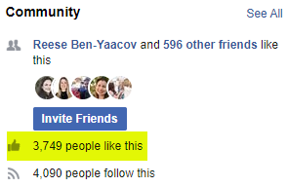
   2. Go to > Insights > Update date to “Last 28 Days”  > get the Post Engagement data
2. Log in as Sarah on Facebook (switch to Classic Facebook)
   1. Go to the Confident OBM Community Facebook group > on the left side of the screen, click Growth Insights > click the box for Total Members > update the time frame to “Custom” and change it to last month > get the Total Members data
   2. Click the box for Posts, Comments & Reactions > update the time frame to “Custom” and change it to last month > click “All”  > Add the figures for Posts, Comments, and Reactions and the sum will be saved in the Metrics spreadsheet
3. Log in to Pinterest
   1. Go to Community > get total Followers
   2. Go to Analytics > Overview > Update the Date Range to last month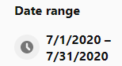 > get Engagements and Total Audience data
   3. Go to Ontraport > go the “Z: Metrics - Pinterest Opt-ins” contact group > get data
      1. Make sure to check by clicking on “Edit Group”. In this metric, the filter should only be “First Lead Source is Equal To Pinterest”
   4. On the same contact group “Z: Metrics - Pinterest Opt-ins”, add a condition that Contact Tags must be Equal to Purchase Behavior - Any Purchase 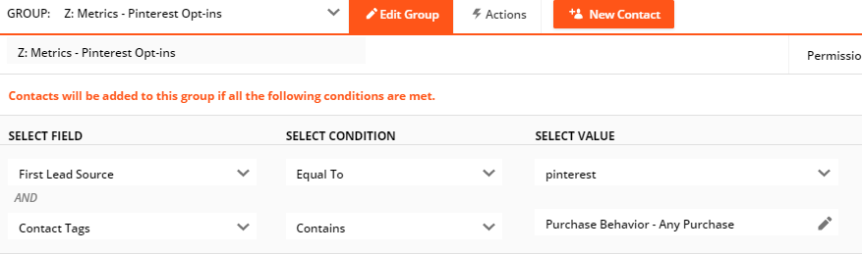 > gather the data
      1. Make sure to check by clicking on “Edit Group”. In this metric, the filter should be “First Lead Source is Equal To Pinterest” and “Contact Tags Contains Purchase Behaviour - Any Purchase”
4. Log in to Instagram
   1. Get total followers
5. Log in to LinkedIn
   1. Click on My Network > get the number of Connections
   2. Click on the Home icon  > click on the Sarah Noked Online Business Manager link on the left side of the screen 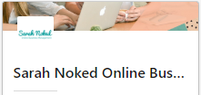 > Click Analytics, then Followers > get total Followers data

**Part 2: Sign in to** [**Google Analytics**](https://analytics.google.com/analytics/web/) **-** [**sarah@sarahnoked.com**](mailto:sarah@sarahnoked.com) **and pull metrics**

1. Make sure to switch to Sarah’s account 
2. Make sure it says All Accounts > Sarah Noked 
3. Go to Customization > Dashboards > click on “Sarah Noked Master Metrics” that was created Feb 3, 2019 > Update the date range to last month 
4. Go through the needed data, it should all be shown in just one dashboard

**Part 3: Sign in to** [**Ontraport**](https://ontraport.com/) **and Pull Metrics**

1. Go to Contacts > Sequences
2. Choose “MARKETING: Newsletter Emails” > gather the needed data
3. Go back and click on Dashboard > go the the Unsubscribes board > update the date to Last Month 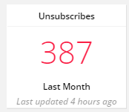> gather data

**Part 4: Finalize Conversion Rates and Include Comments on Findings**

1. Leave any appropriate notes under the Comments tab
2. Color the stats **green** for positive/increased results and **red** showing negative/decreased results.

**Part 5: Report Monthly Metrics**

Sarah and Charmaine have a recurring weekly agenda task to discuss metrics

**Created by:**

**Department:** Metrics

**Date:**

**Revised:**

**Revised by:**